Chapter 1, Solution 16

(a)
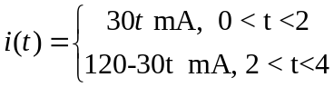

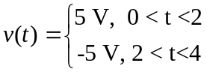

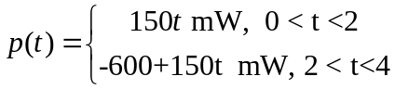

which is sketched below.

p(mW)
1
2

300

4 t (s)

-300

- From the graph of p,
